1. The main goal of this step is simply to create a functional app that connects to the database and retrieves the specified data from the stored procedures. It can all be plain text for this step.

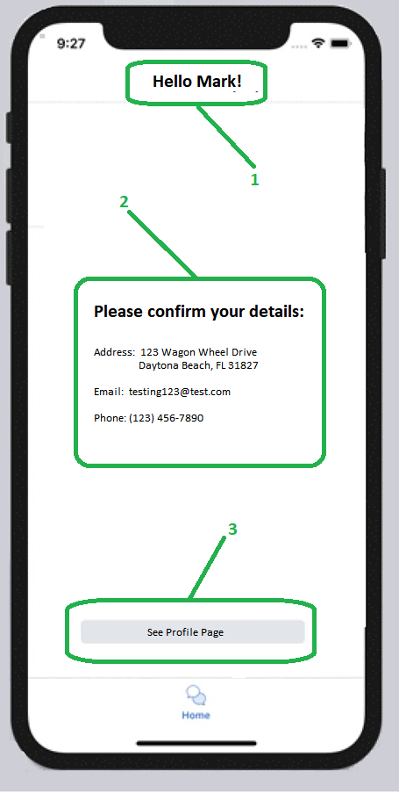

1. This should display the first name from the stored procedure. A user should log in with their email address. Sending the email address to the stored procedure will get back the user details. For this item, we just display their first name.
2. The center portion of the screen should display the rest of the values returned from the stored procedure which will be the address, email, and phone number.
3. Clicking on the ‘See Profile Page’ will load the next screen below.
4. When the user clicks on the ‘See Profile Page’ it should load the page below.

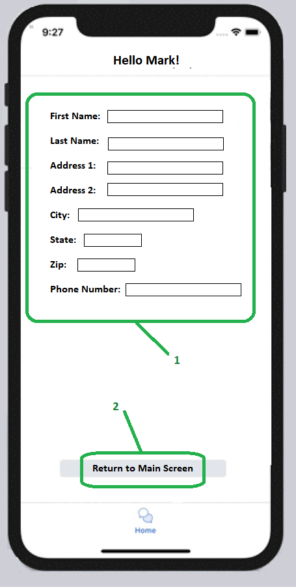

**1**

1. Here it should load whatever data we have saved for the user, but it will allow them to overwrite the values. Whenever the user clicks ‘Return to Main Screen’, the app should update the database with whatever values have been changed.
2. Clicking on ‘Return to Main Screen’ simply brings you back to the page above.